Once you insert and boot your machine with the RHEL DVD, you will get the below screen. Select "**Install Red Hat Enterprise Linux 7.0**" and Press "**Enter**".

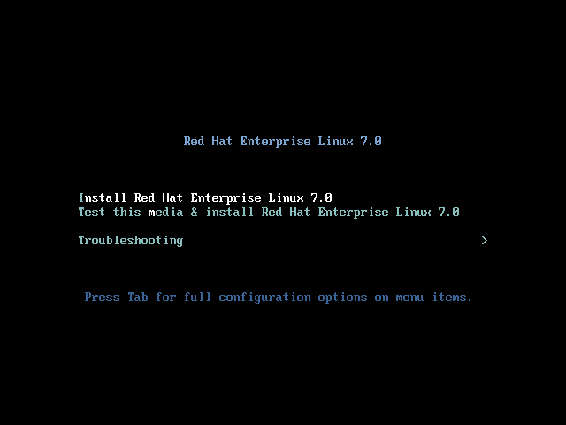

As you see the installation process is initiated

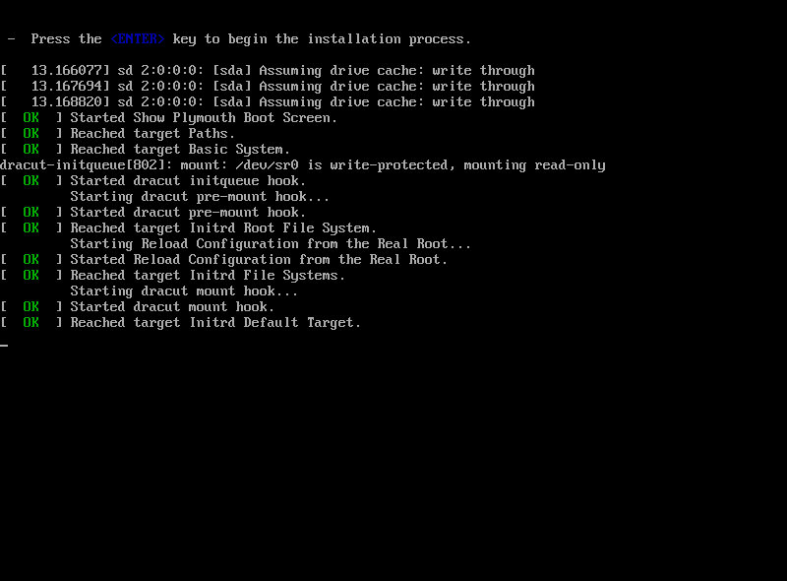

Select the **Language** preference

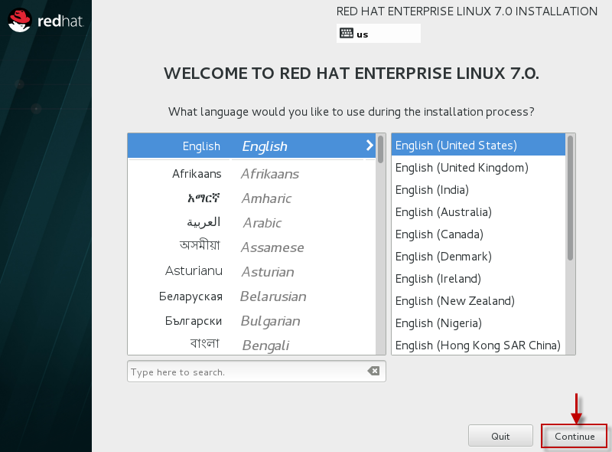

The Next screen contains almost all the configuration which has to be performed for the installation. Since we have already selected our **Language** and **Keyboard** preferences, we can skip that step here.

Lets start by setting the **Date and Time**

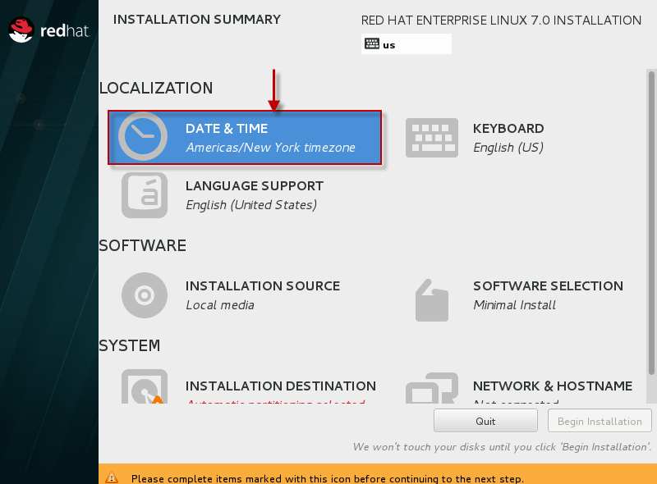

Select your **Location** as for me it is **Asia/Kolkatta**

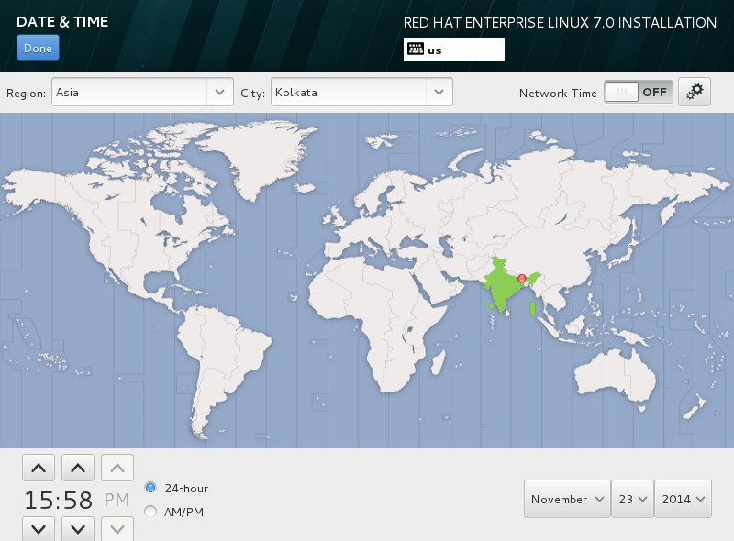

Next we will select the packages which we want to install. So Select "**Software Installation**" which will lead you to the below screen. In my case I will install the "**Base Installation**" package having "**Server with GUI**" and in case you want to add any extra Add On, you can select the same from the left panel as shown below.

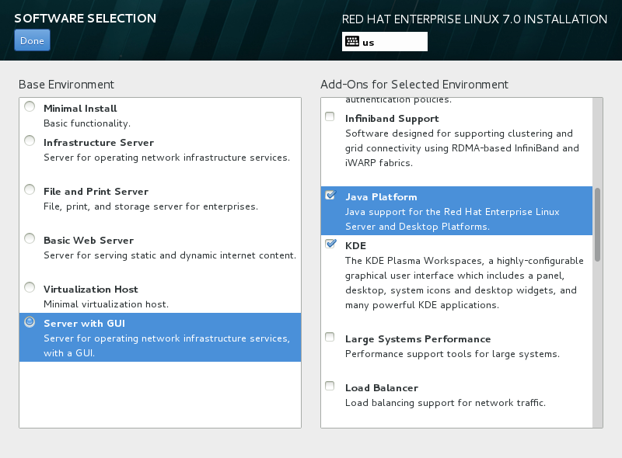

Next we need to configure partitions. So select "**Installation Destination**"

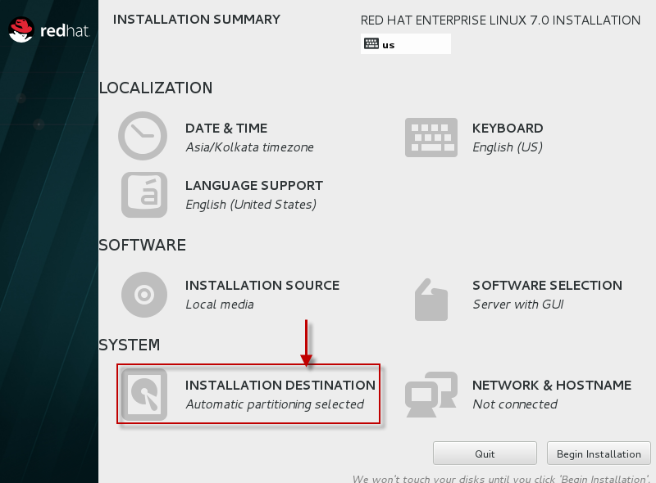

Select the hard disk which you have used to install RHEL 7, as for my case as you can see 20GB hard drive.

Also if you want the OS to automatically create the partition select the same or else for this article lets **manually create the partitions**

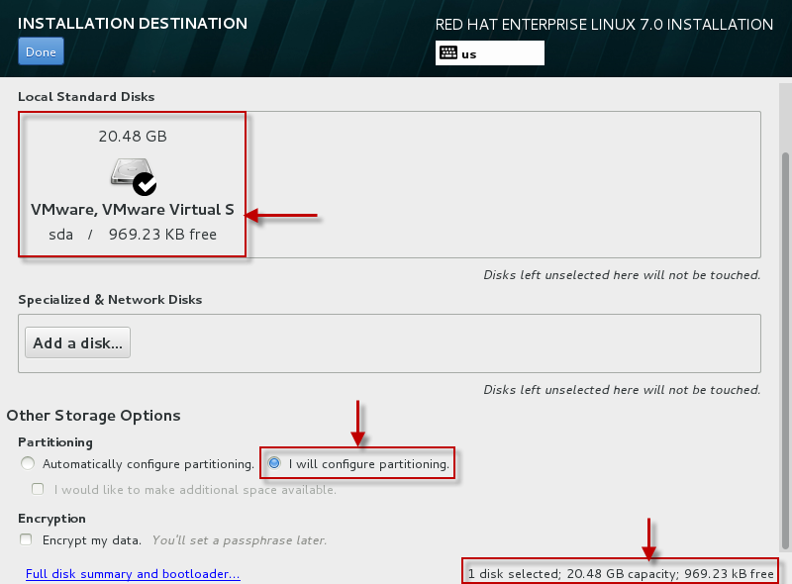

You can create a partition with the below list of partition types. As for this article we will select **LVM**

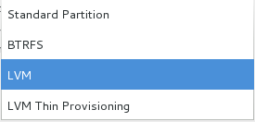

Click on the "**+**" sign to add new partition.

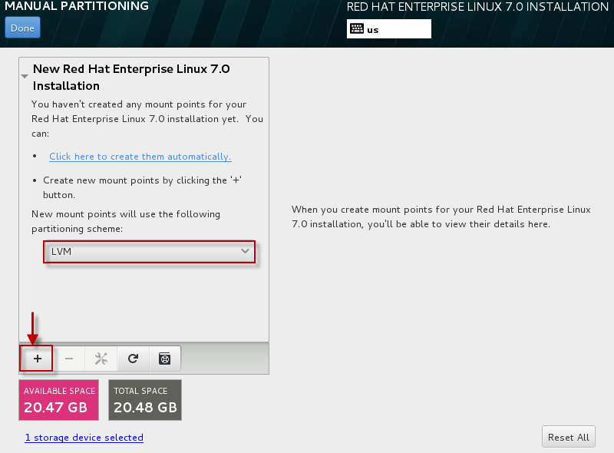

For this article I will create**/boot**, **/**, **swap** partition under LVM with Volume Group name as "**VolGroup00**"

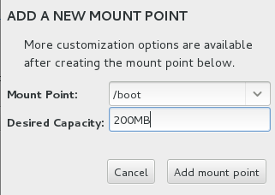

Change the partition type to **Ext4** as by default **XFS** will be selected for every partition you create.

Once you change these settings make sure you "**update settings**"

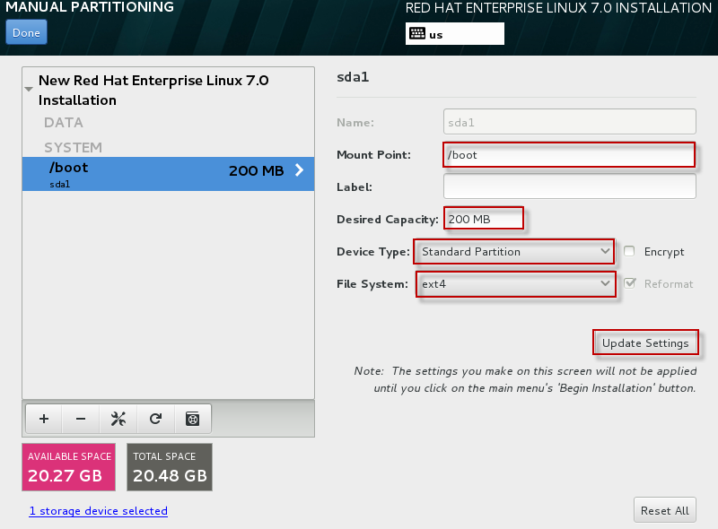

By default Volume Group name is "**rhel**". Let us change it to "**VolGroup00**"

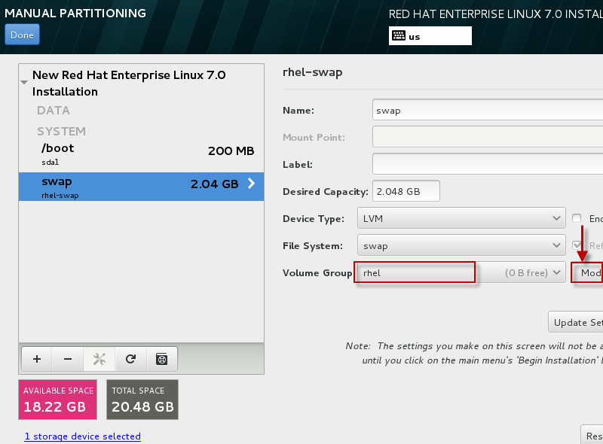

You can also configure the storage for **RAID** but let us skip that part as of now.

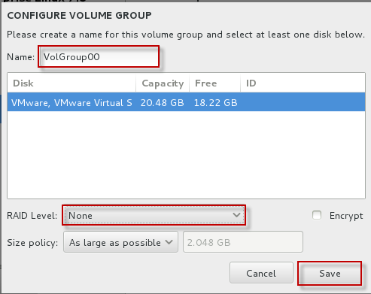

As you see all the mount points as planned are created with below name under LVM  
**VolGroup00-root**  
**VolGroup-swap**

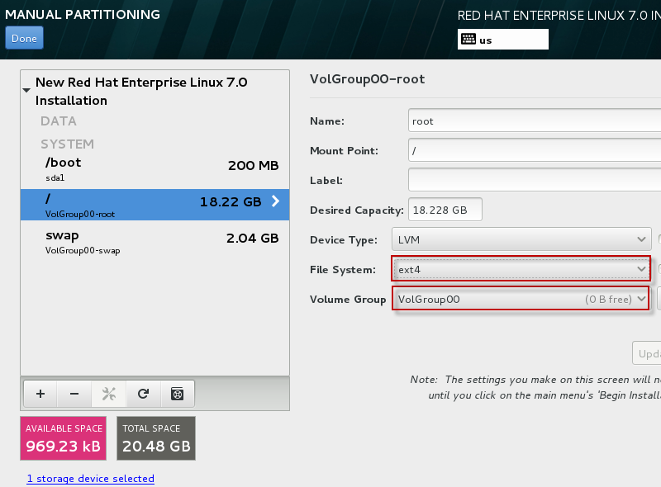

Click on **Done**and select **Accept Changes.**

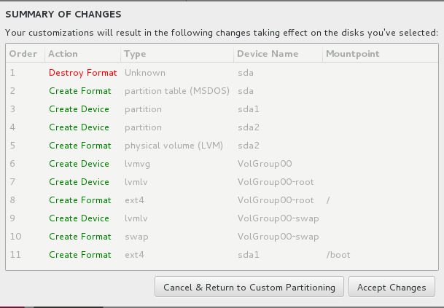

The last one is to **Configure Network**

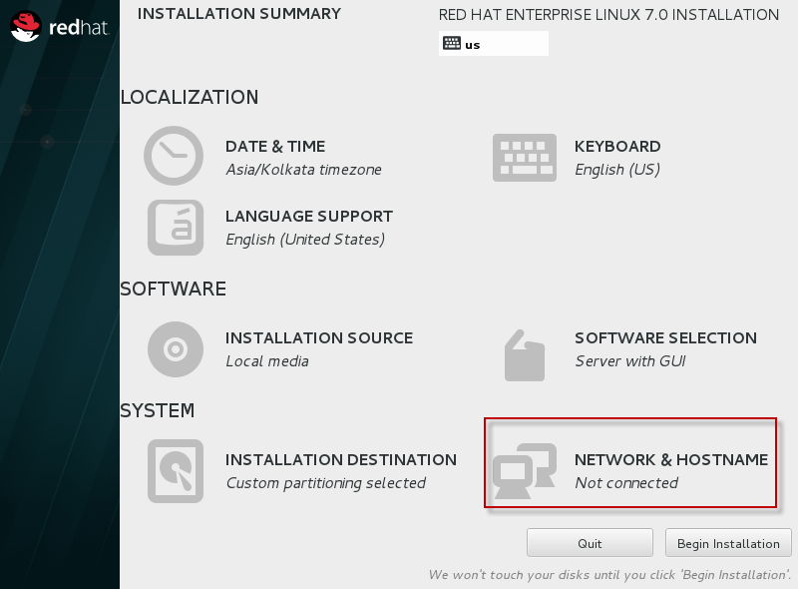

Provide a **hostname** for your machine and enable the **ethernet device.**Next select **Configure** to configure network settings for your machine

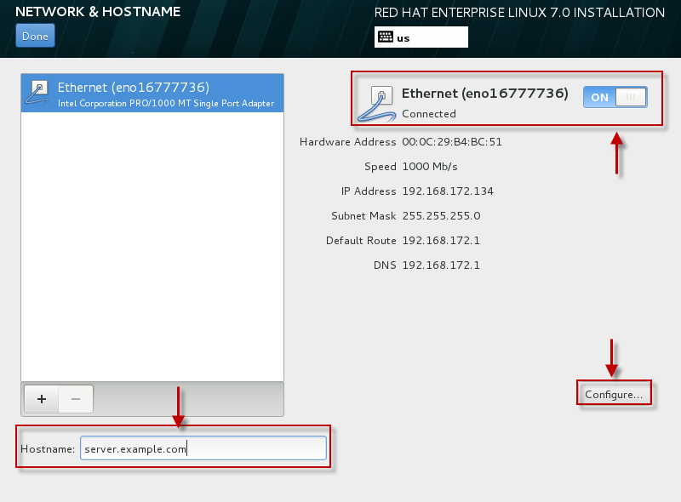

Change the Ethernet device name or else you can skip that part. Next configure you IP details as per your environment i.e IPv4 or [IPv6](https://www.golinuxcloud.com/how-to-configure-ipv6-address-in-linux-rhel-centos-7/). We are using IPv4 so selected the "**IPv4 Settings**" and added the **IP**, **Netmask**,**Gateway** and **DNS** details in the same.. Click on "**Done**" to save the configuration and go a step back.

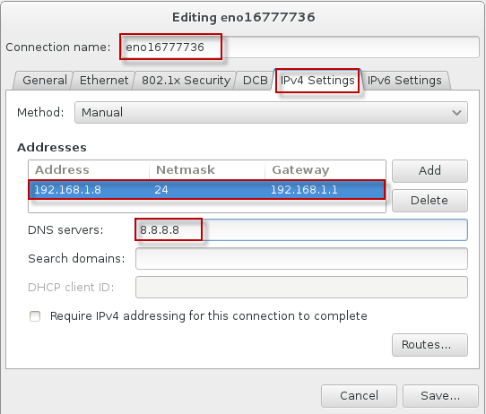

So we are done here with all the options on this screen. Next we can "**Begin Installation**"

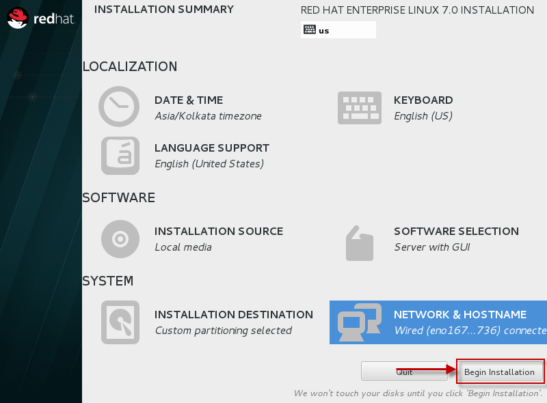

As you see the installation has begun in the mean time you can add a password for your **root** user. Also you can create additional user by using the "**User Creation**" thumbnail.

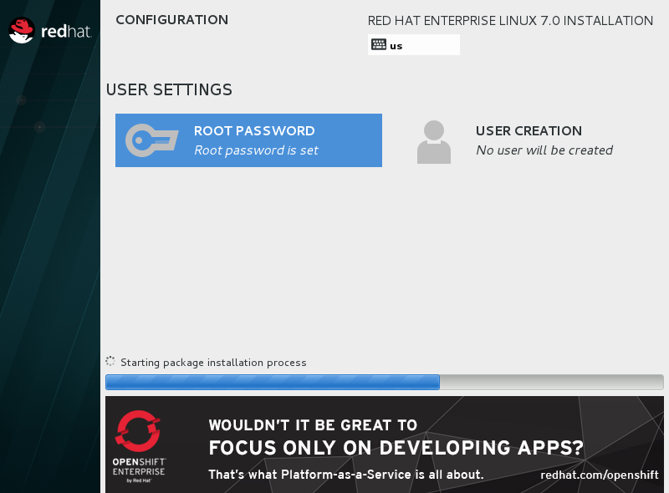

Provide a password for root account.

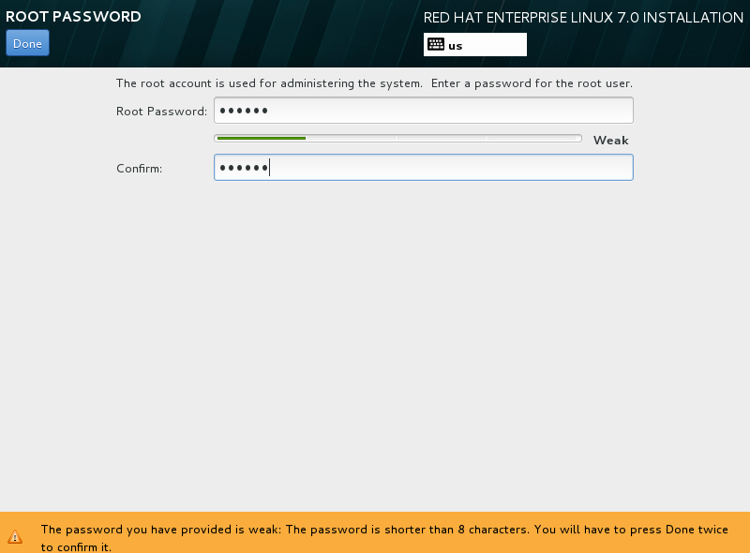

Create a user.(Optional)

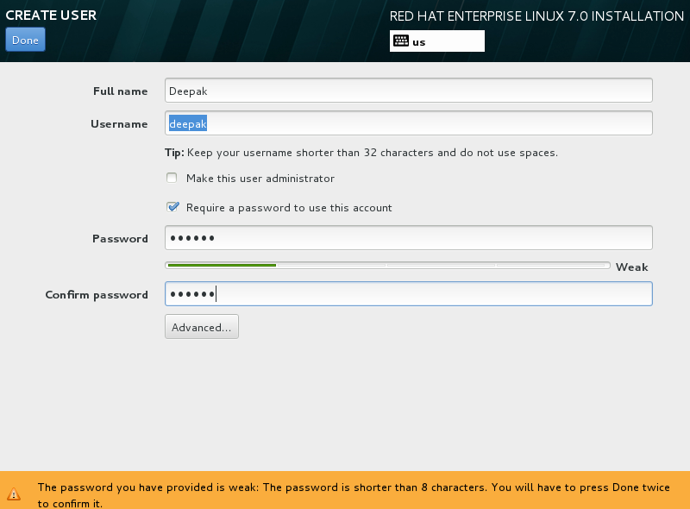

In the mean time let the installation complete. Once done click on **Reboot**.

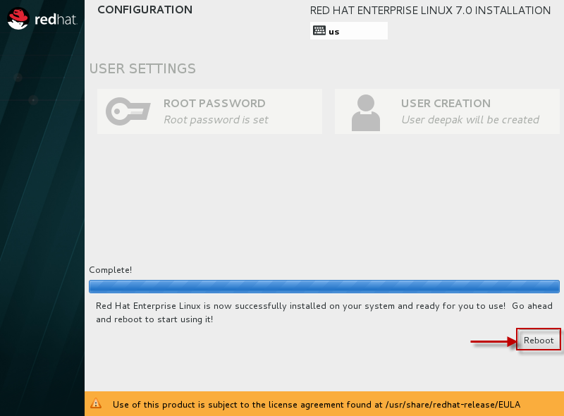

Once the machine reboots, next it will prompt the below screen. Click on "**License Information**"

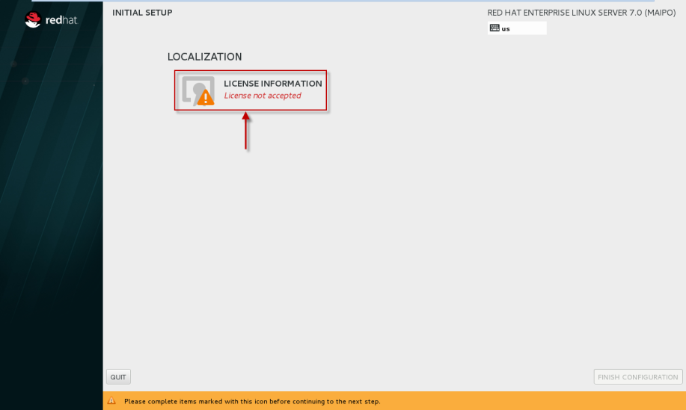

**Accept**the Terms and Conditions

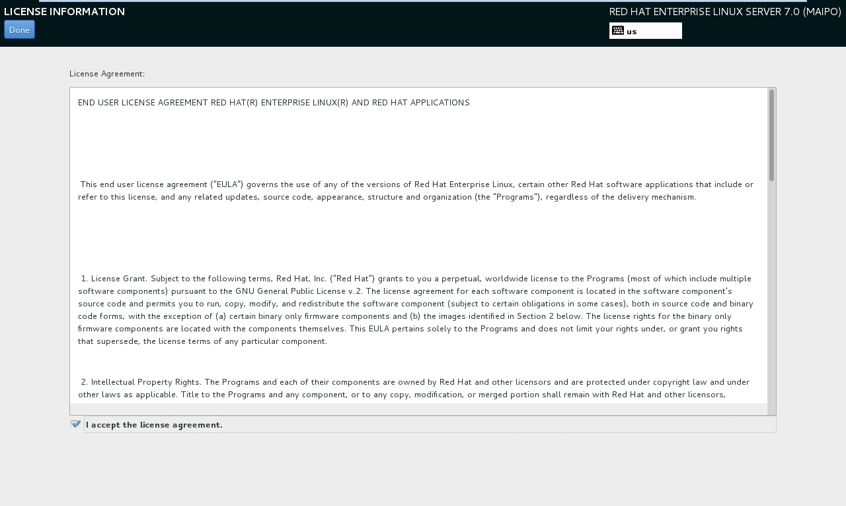

Click on "**Finish Configuration**"

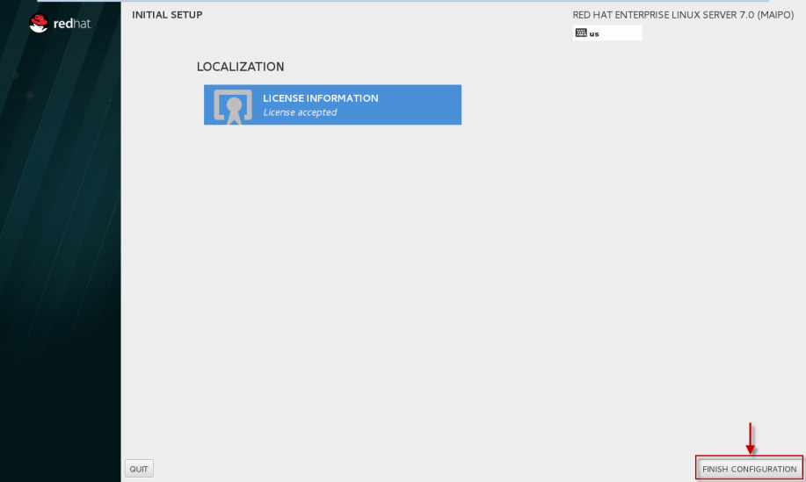

Next you will get the **Kdump** configuration page.

Let us **enable the Kdump** and let the machine decide the amount of memory required for the same.

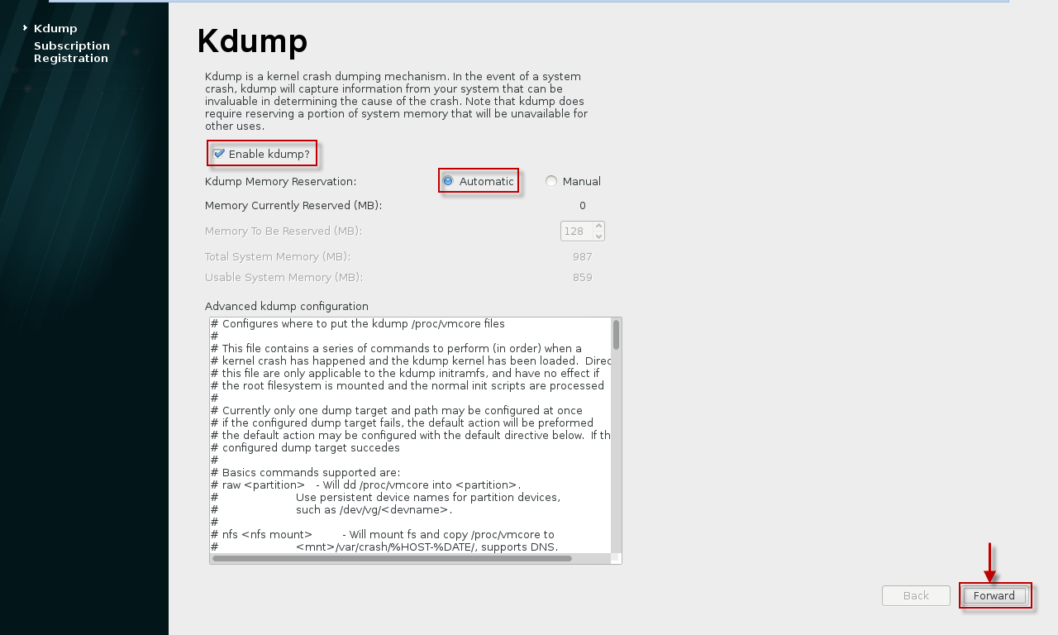

I do not want to register my system to RHN as for now,also we can perform this step later so let us skip this part for now.

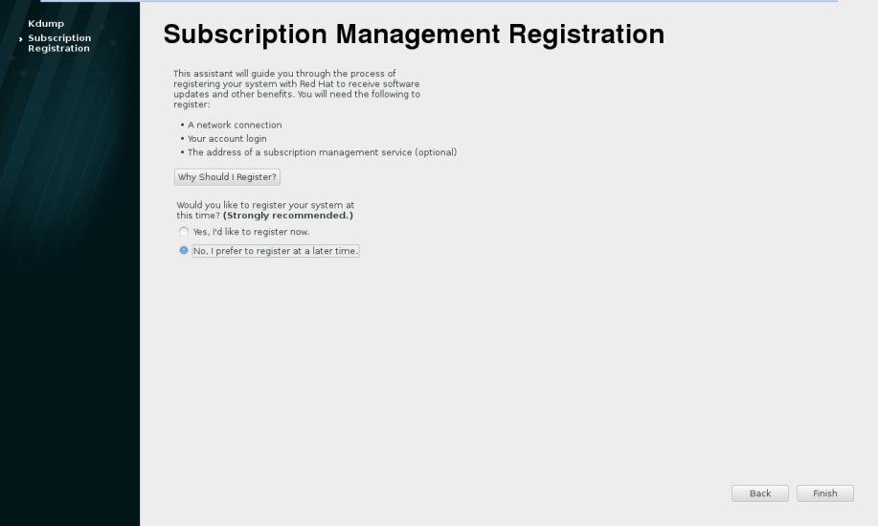

Next you get your **Login Screen** which means we have successfully installed our Operation System i.e. **RHEL 7.0 (64 bit).**

